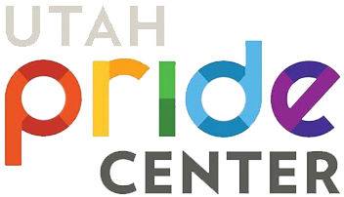

“Utah Pride unites, empowers and celebrates Utah’s diverse LGBTQ+ community by providing a safe and welcoming space for education, partnerships, services and events which advance our collective health, wellness and success.”

Our Vision:
“A thriving LGBTQ+ community in Utah.”

Our Objectives:
HEALTH
Encourage and promote the physical, emotional, and mental health & wellness of the LGBTQ+ community through programs which support and nurture the mind, body and soul.
EDUCATION
Provide educational opportunities for members of the LGBTQ+ and allied communities in an effort to promote a greater understanding of topics unique to Utah’s LGBTQ+ community.

UNITY
Unite and empower members of the LGBTQ+ and allied communities through meaningful programs and celebratory events.

PARTNERS
Partner with community organizations to deliver and promote programs and resources beneficial to the LGBTQ+ community.

SPACE
Provide the LGBTQ+ community with a safe space (The Center) full of tangible resources meant to help the community thrive.

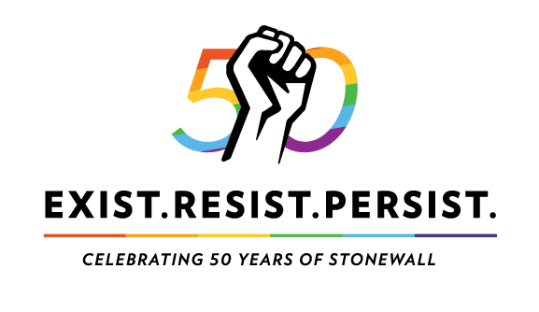
A program of The Utah Pride Center, The Utah Pride Festival is a community event which features a broad spectrum of activities and entertainment. The 44th Utah Pride Festival will be held June 1st & 2nd, 2019 at Washington Square in downtown Salt Lake City. Pride 2019 is excited to offer additional celebratory events, diverse food and booth vendors, venue upgrades and excellent entertainment options!

History of the Utah Pride Festival

From its humble beginnings in 1974 as an informal gathering in the park, the Utah Pride Festival has come a long way. It is now a major Salt Lake City event that grows bolder and brighter every year. The Festival empowers the LGBTQ+ community of Salt Lake, as well as the state of Utah as a whole, to come together and celebrate. The Festival is now attended by more than 50,000 people and continues to grow each year. In 2018, the Pride Parade attracted 50,000 spectators. A broad spectrum of people can be found at all these events, including members of the LGBTQ+ community, their family members and allies.

Benefits of Participation:
- Advertise our programs to a community that is known to be loyal to providers that offer LGBTQ+ friendly and affirmative services.
- 4.7% of Salt Lake City’s population identify as LGBTQ+ and 3.7% of Utah’s population identify as LGBTQ+. These numbers are grossly underestimated due to underreporting. But this means about 82,000 individuals in the state of Utah are actively looking for programs and services that serve their community.
- This is the first year that the University of Utah is coordinating a large presence at this event (both the festival and parade). This means we will have other U of U departments there to help raise our brand presence.
- Continuing Education has LGBTQ+ identified employees and allies, as a community driven organization we have the opportunity to show our support to all the diverse communities we serve and employ.
- The University of Utah marketing department has already done the heavy lifting in regards to the application process and payment

Ask:
- 2 rotating employees to staff the booth Saturday from 1pm-11pm and Sunday 11am-7pm, this can be done in 2 hour or longer shifts, which would add up to 9 total shifts.
- Encourage any employees and family members who are able, to walk in the parade with the rest of the University of Utah departments. The parade is on Sunday at 10am.
- A donation of $650 to help cover the cost of a booth.

Please notify me by Monday, April 29th. I am working directly with the marketing department coordinating these efforts.
Thank you for considering this opportunity for our organization.
Ariel Malan
ariel.malan@utah.edu
801-585-7087

http://www.lgbtmap.org/equality_maps/profile_state/UT

